Goals and main task(s): Create renderers that will draw the previously-created graphical data

structures.

Tasks: Created forward renderer

Reflections: I created a forward renderer, which draws each mesh one-by-one and computes light calculations on the mesh. Thus the scene complexity of this renderer is: O(geometry * lights). This renderer is the only three-dimensional renderer currently implemented. The code for its rendering process is shown below.

Tasks: Created GUI manager

Reflections: In addition to a three-dimensional graphics renderer, I also created a GUI manager that uses the imgui library to construct vertex buffers and then draw them to the screen. The GUI manager renders fonts and can display diagnostic information. The code for its rendering process is shown below.

Below: The forward renderer drawing simple meshes

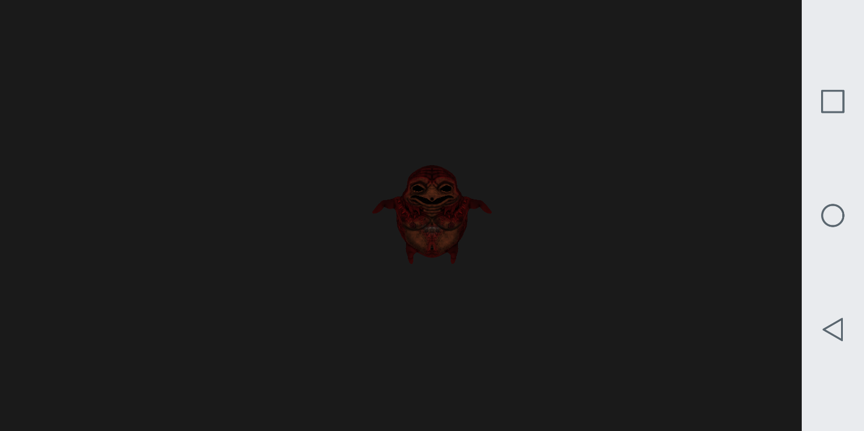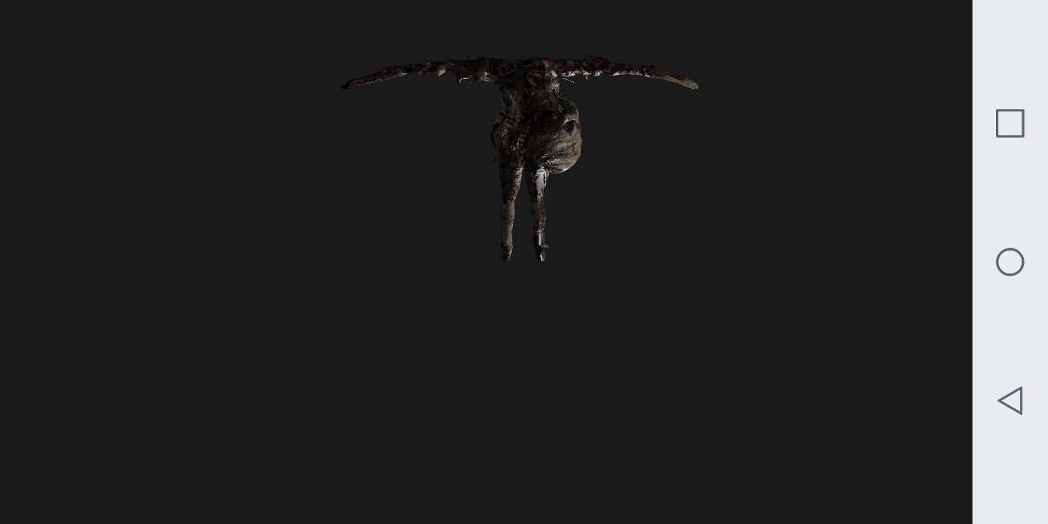

Below: The GUI Manager displaying diagnostics

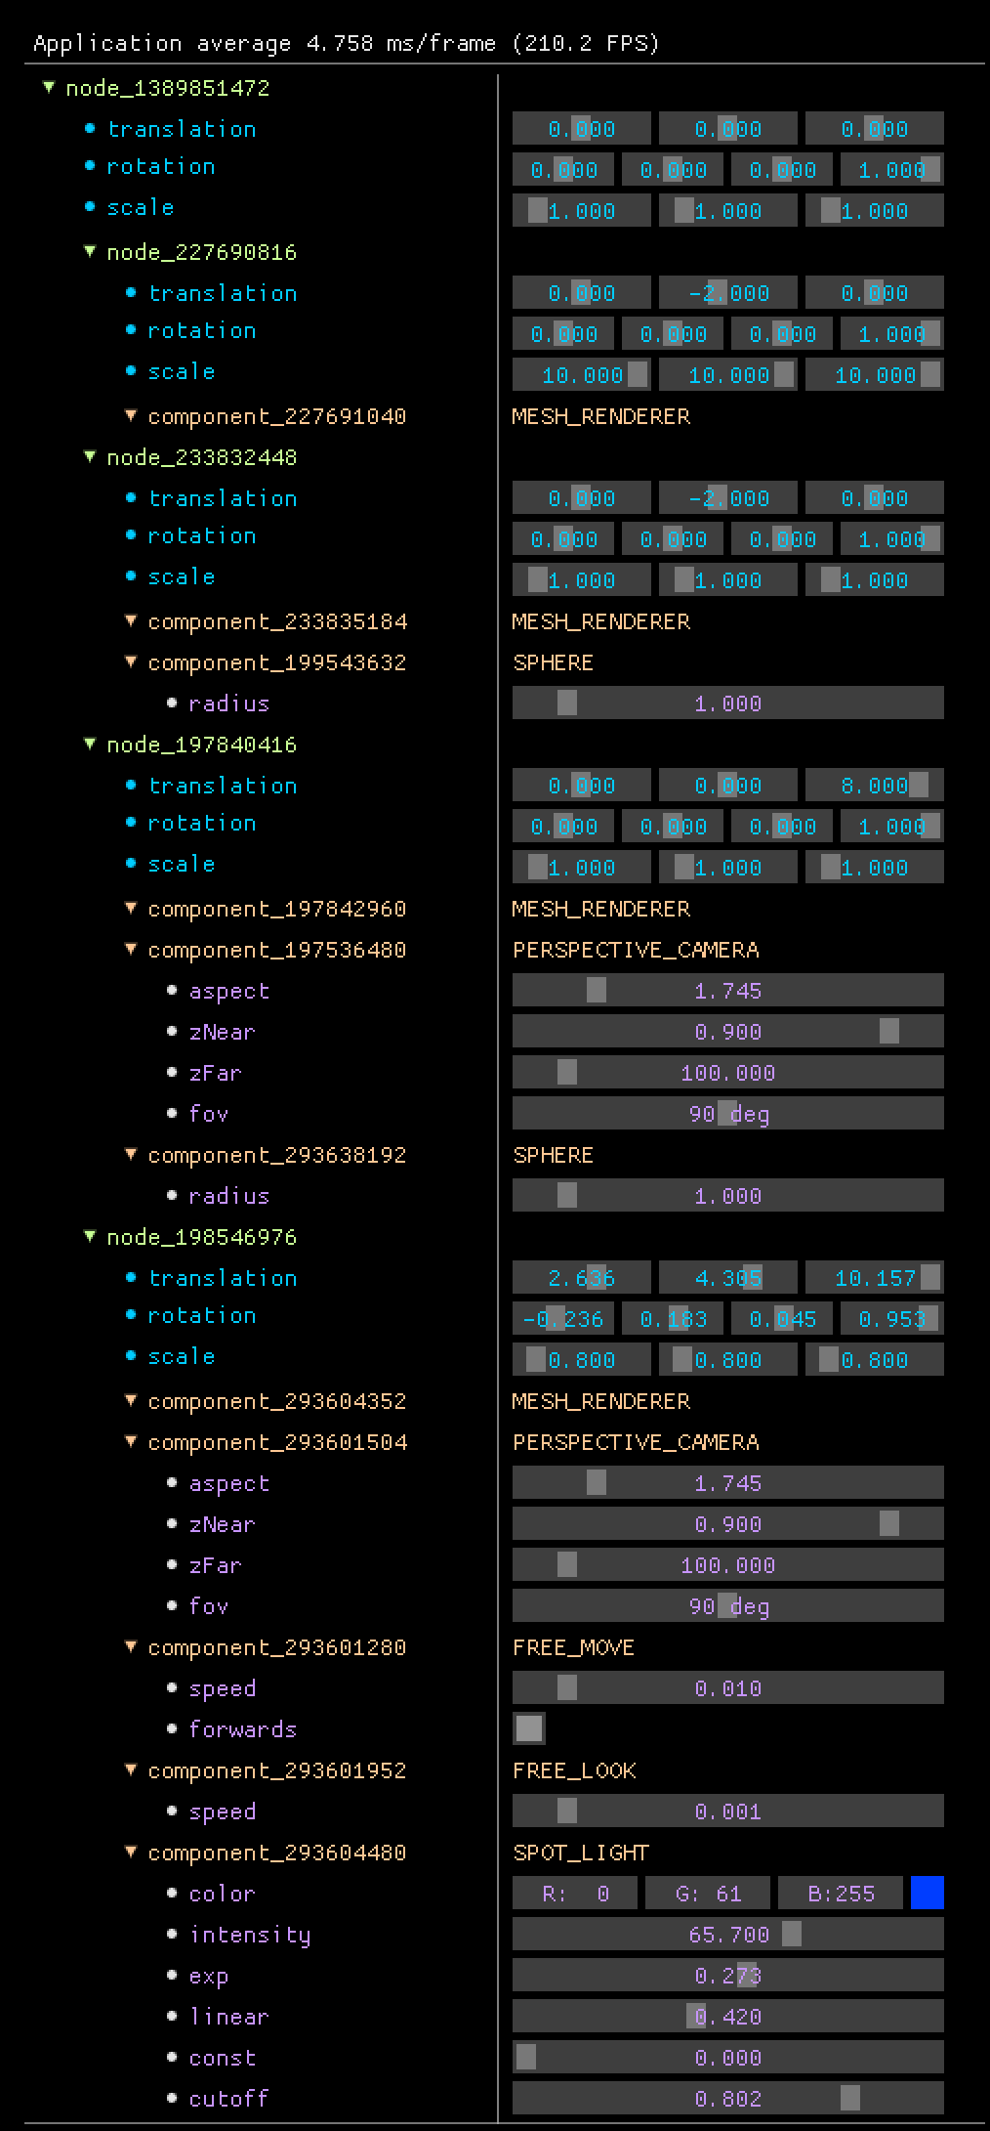

Below: The forward rendering process

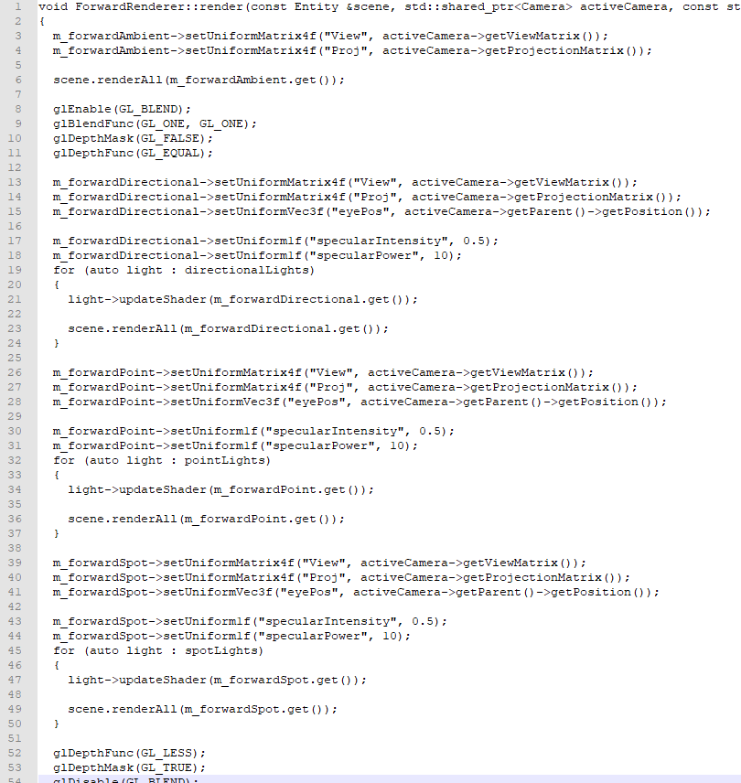

Below: The GUI manager rendering code. It contains some android-specific code by using the GLES2 define

void GuiManager::renderDrawLists(ImDrawData *draw_data)

{

// Avoid rendering when minimized, scale coordinates for retina displays (screen coordinates != framebuffer coordinates)

ImGuiIO &io = ImGui::GetIO();

int fb_width = (int)(io.DisplaySize.x * io.DisplayFramebufferScale.x);

int fb_height = (int)(io.DisplaySize.y * io.DisplayFramebufferScale.y);

if (fb_width == 0 || fb_height == 0)

return;

draw_data->ScaleClipRects(io.DisplayFramebufferScale);

// Backup GL state

GLint last_program;

glGetIntegerv(GL_CURRENT_PROGRAM, &last_program);

GLint last_texture;

glGetIntegerv(GL_TEXTURE_BINDING_2D, &last_texture);

GLint last_active_texture;

glGetIntegerv(GL_ACTIVE_TEXTURE, &last_active_texture);

GLint last_array_buffer;

glGetIntegerv(GL_ARRAY_BUFFER_BINDING, &last_array_buffer);

GLint last_element_array_buffer;

glGetIntegerv(GL_ELEMENT_ARRAY_BUFFER_BINDING, &last_element_array_buffer);

#if !defined(GLES2)

GLint last_vertex_array;

glGetIntegerv(GL_VERTEX_ARRAY_BINDING, &last_vertex_array);

GLint last_blend_src;

glGetIntegerv(GL_BLEND_SRC, &last_blend_src);

GLint last_blend_dst;

glGetIntegerv(GL_BLEND_DST, &last_blend_dst);

#endif

GLint last_blend_equation_rgb;

glGetIntegerv(GL_BLEND_EQUATION_RGB, &last_blend_equation_rgb);

GLint last_blend_equation_alpha;

glGetIntegerv(GL_BLEND_EQUATION_ALPHA, &last_blend_equation_alpha);

GLint last_viewport[4];

glGetIntegerv(GL_VIEWPORT, last_viewport);

GLboolean last_enable_blend = glIsEnabled(GL_BLEND);

GLboolean last_enable_cull_face = glIsEnabled(GL_CULL_FACE);

GLboolean last_enable_depth_test = glIsEnabled(GL_DEPTH_TEST);

GLboolean last_enable_scissor_test = glIsEnabled(GL_SCISSOR_TEST);

// Setup render state: alpha-blending enabled, no face culling, no depth testing, scissor enabled

glEnable(GL_BLEND);

glBlendEquation(GL_FUNC_ADD);

glBlendFunc(GL_SRC_ALPHA, GL_ONE_MINUS_SRC_ALPHA);

glDisable(GL_CULL_FACE);

glDisable(GL_DEPTH_TEST);

glEnable(GL_SCISSOR_TEST);

glActiveTexture(GL_TEXTURE0);

// Setup orthographic projection matrix

glViewport(0, 0, (GLsizei)fb_width, (GLsizei)fb_height);

auto ortho_projection = glm::ortho(0.0f, io.DisplaySize.x, io.DisplaySize.y, 0.0f);

m_shader->bind();

m_shader->setUniform1i("Texture", 0);

m_shader->setUniformMatrix4f("ProjMtx", ortho_projection);

#if !defined(GLES2)

glBindVertexArray(g_VaoHandle);

#else

glBindBuffer(GL_ARRAY_BUFFER, g_VboHandle);

glEnableVertexAttribArray(g_AttribLocationPosition);

glEnableVertexAttribArray(g_AttribLocationUV);

glEnableVertexAttribArray(g_AttribLocationColor);

#define OFFSETOF(TYPE, ELEMENT) ((size_t) & (((TYPE *)0)->ELEMENT))

glVertexAttribPointer(g_AttribLocationPosition, 2, GL_FLOAT, GL_FALSE, sizeof(ImDrawVert), (GLvoid *)OFFSETOF(ImDrawVert, pos));

glVertexAttribPointer(g_AttribLocationUV, 2, GL_FLOAT, GL_FALSE, sizeof(ImDrawVert), (GLvoid *)OFFSETOF(ImDrawVert, uv));

glVertexAttribPointer(g_AttribLocationColor, 4, GL_UNSIGNED_BYTE, GL_TRUE, sizeof(ImDrawVert), (GLvoid *)OFFSETOF(ImDrawVert, col));

#undef OFFSETOF

#endif

for (int n = 0; n < draw_data->CmdListsCount; n++)

{

const ImDrawList *cmd_list = draw_data->CmdLists[n];

const ImDrawIdx *idx_buffer_offset = 0;

glBindBuffer(GL_ARRAY_BUFFER, g_VboHandle);

glBufferData(GL_ARRAY_BUFFER, (GLsizeiptr)cmd_list->VtxBuffer.size() * sizeof(ImDrawVert), (GLvoid *)&cmd_list->VtxBuffer.front(), GL_STREAM_DRAW);

glBindBuffer(GL_ELEMENT_ARRAY_BUFFER, g_ElementsHandle);

glBufferData(GL_ELEMENT_ARRAY_BUFFER, (GLsizeiptr)cmd_list->IdxBuffer.size() * sizeof(ImDrawIdx), (GLvoid *)&cmd_list->IdxBuffer.front(), GL_STREAM_DRAW);

for (const ImDrawCmd *pcmd = cmd_list->CmdBuffer.begin(); pcmd != cmd_list->CmdBuffer.end(); pcmd++)

{

if (pcmd->UserCallback)

{

pcmd->UserCallback(cmd_list, pcmd);

}

else

{

m_textureData->bind(0);

glScissor((int)pcmd->ClipRect.x, (int)(fb_height - pcmd->ClipRect.w), (int)(pcmd->ClipRect.z - pcmd->ClipRect.x), (int)(pcmd->ClipRect.w - pcmd->ClipRect.y));

glDrawElements(GL_TRIANGLES, (GLsizei)pcmd->ElemCount, sizeof(ImDrawIdx) == 2 ? GL_UNSIGNED_SHORT : GL_UNSIGNED_INT, idx_buffer_offset);

}

idx_buffer_offset += pcmd->ElemCount;

}

}

#if defined(GLES2)

glDisableVertexAttribArray(g_AttribLocationPosition);

glDisableVertexAttribArray(g_AttribLocationUV);

glDisableVertexAttribArray(g_AttribLocationColor);

#endif

// Restore modified GL state

glUseProgram(last_program);

glActiveTexture(last_active_texture);

glBindTexture(GL_TEXTURE_2D, last_texture);

#if !defined(GLES2)

glBindVertexArray(last_vertex_array);

#endif

glBindBuffer(GL_ARRAY_BUFFER, last_array_buffer);

glBindBuffer(GL_ELEMENT_ARRAY_BUFFER, last_element_array_buffer);

glBlendEquationSeparate(last_blend_equation_rgb, last_blend_equation_alpha);

#if !defined(GLES2)

glBlendFunc(last_blend_src, last_blend_dst);

#endif

if (last_enable_blend)

glEnable(GL_BLEND);

else

glDisable(GL_BLEND);

if (last_enable_cull_face)

glEnable(GL_CULL_FACE);

else

glDisable(GL_CULL_FACE);

if (last_enable_depth_test)

glEnable(GL_DEPTH_TEST);

else

glDisable(GL_DEPTH_TEST);

if (last_enable_scissor_test)

glEnable(GL_SCISSOR_TEST);

else

glDisable(GL_SCISSOR_TEST);

glViewport(last_viewport[0], last_viewport[1], (GLsizei)last_viewport[2], (GLsizei)last_viewport[3]);

}